Virtual Caring for Our Own
Meeting 7 Sculpting Activity Modification
Activity B-2, Pages 7-25 to 7-35 (Process Points #21-#74)

Introduce the activity:

- Now that we have talked generally about chemical dependence, we are going to consider specific ways in which it affects families.

- We know that in families where chemical dependence is an issue, family members take on roles that help them cope with the chemical dependence.

- We will use a visual activity to demonstrate what happens in a family that is affected by chemical dependence.

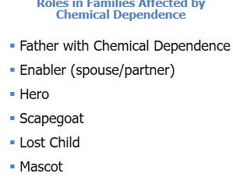 | We are going to look at common roles family members assume when someone in the family is chemically dependent.  The “Enabler” is often supportive of the person with chemical dependence. As the name implies, the Enabler enables the dependency to continue.  The “Hero” is the person in the family upon whom many depend.  The “Scapegoat” often takes on the problems of the entire family.  The “Lost Child” as the name implies, is often quiet and withdraws from the family.  The “Mascot” keeps the family’s attention diverted from its problems.
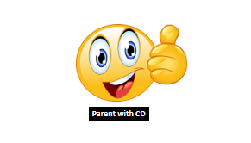 | In many families, one or both parents, or a parent’s significant other, might be using drugs or is addicted to drugs.  In this family the father is chemically dependent.
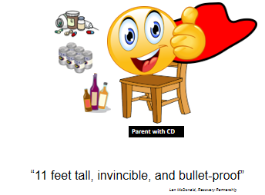 | Now you see the father standing on a chair. He feels very powerful and in control which is usually what the drug does for him when he is using it.  It has been said that using drugs can make you feel “11 feet tall, invincible, and bullet-proof”
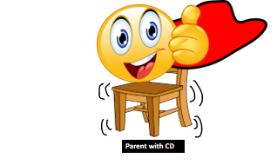 |  | If I shake the chair that the father is standing on, how do you think he would feel?  Reinforce answers such as:  - Insecure  - Afraid  - Anxious
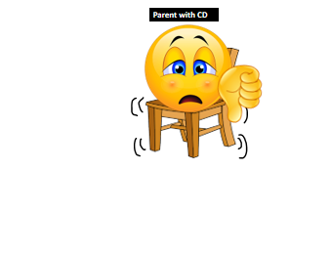 |  | The unsteadiness he feels symbolizes the consequences of the addiction. What might they be?  Reinforce answers such as:  - Driving under the influence (DUI),  - Job conflicts  - Financial problems  If you were this father, what emotion would you feel when the consequences occur?  Reinforce responses such as shame, fear, guilt, or vulnerable.  As the problems continue, Father needs someone to lean on to keep from falling.
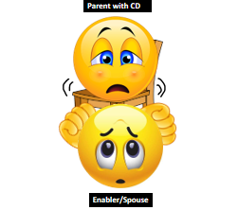 |  | We see that the Enabler, his spouse, stands directly in front of him and keeps him from falling over because he puts his hands on her shoulders.  Now when the chair is shaken, he feels more secure and protected from the consequences of his drug use.
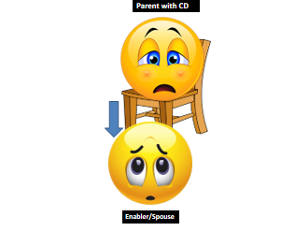 |  | Now, let’s imagine that the Enabler steps away a little from the father.  How might the father act when the Enabler steps away?  He will probably hang on tighter.  How might the father get the Enabler to remain where she is, holding him up?  Reinforce responses such as:  - Make promises to her, threaten her  - Tell her how much he needs her  - Being extra nice to her

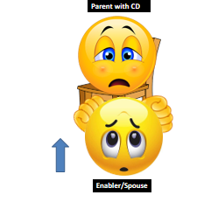 | We see that the Enabler decides to remain with the father. Research shows that women are more likely than men to stay in relationships where there is chemical dependence.  How do you think the Enabler might feel?  Reinforce responses such as angry, inadequate, powerless, confined  What would happen to the father if the Enabler were able to actually walk away?  Reinforce responses such as:  - He might get help and stop denying his problem.  - She might be blamed by family and friends for walking out on him.  - She might come back when nothing has changed.
Let’s look at the rest of the family now.

We will focus on the children who are born into this family where there is alcoholism and/or other drug addiction, and to show the roles they adopt in trying to survive with a parent who is chemically dependent.

The Hero is usually the oldest child, who tries to earn the love of their parents by being responsible, always doing good, and trying to make the family look good to the outside world.

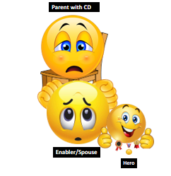 | We see the Hero link arms with the Enabler to give support.  What kinds of things do you think the Hero tries to do in this family?  Reinforce responses such as:  - Make good grades  - Help around the house  - Do whatever they can do to please the father and share the Enabler’s burden  However, no matter how good or perfect the Hero is, the family does not change.  How do you think the Hero might feel in this role?  Reinforce responses such as:  - A sense of failure  - Over-responsible  - Pressure to perform  - Unable to express how they are feeling or what is happening in their family
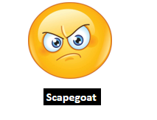 | Next, we have the Scapegoat, who soon realizes that there is no way he or she can get attention by being as good as the Hero.  Hence, being bad is the only way to get attention in this family.  The Scapegoat feels isolated from the family and blames them for his or her behavior, while the family blames the Scapegoat for the problems in the family.
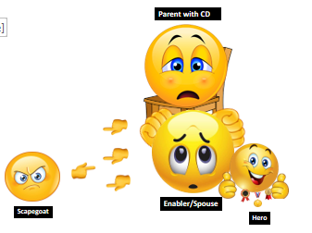 | We see that the Scapegoat stands apart from the family, pointing at them angrily, while the rest of the family point accusing fingers back at the Scapegoat.  What kind of things do you think the Scapegoat does in this family?  Reinforce responses such as:  - Skips school  - Fights  - Runs away  - Use alcohol or drugs  What useful purpose does the scapegoat serve for the family?  Reinforce responses such as:  - Takes attention away from the parent with chemical dependence.  - Provides a distraction from the real problem.  - Scapegoat becomes an excuse for the parents with chemical dependence to use alcohol or other drugs. (“You drive me to drink”).  How do you think the Scapegoat might feel in this role?  Reinforce responses such as: Anger, Sad, or Lonely
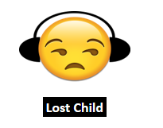 | We will now meet the Lost Child.  The Lost Child cannot compete with either the Hero or the Scapegoat in the family.  The Lost Child learns early on to give up trying to be important and settles for finding ways to isolate him/her-self and seeks self-comfort.

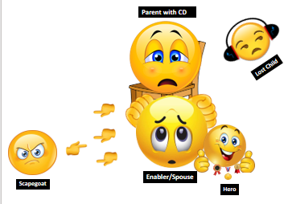 | We see that the Lost Child sits away from the family and listens to music.  How might the Lost Child behave in the family?  Reinforce responses such as:  - Stay in his or her room  - Eat alone  - Stay out of everybody’s way  How do you think the Lost Child might be feel in this role?  Reinforce responses such as:  - Insignificant  - Lonely  - Powerless  - Shy  - Safe from the chaos around him or her
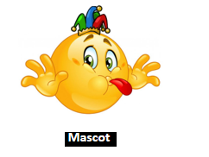 | The Mascot is often the youngest child.  The Mascot learns that the only way to be significant in the family is to give them what they so desperately need---some entertainment and comic relief to distract them from the pain and stress of the disease of chemical dependence.
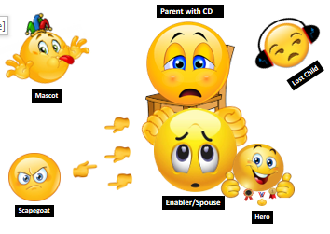 | We see that the Mascot stands in front of the family and makes faces at them and tells jokes to put smiles on their faces.  How might the Mascot behave in this family?  Reinforce responses such as:  - Laugh  - Tell jokes  - Sing and dance  - Cheer people up  - Serve as the life of the party  No matter how hard the Mascot tries to make the family happy, nothing really changes, and the Mascot never gets the attention he or she wants and needs from the family.  How do you think the Mascot might feel in this role?  Reinforce responses such as:  - A sense of failure  - Inadequate  - Lonely  - Fearful  - Angry
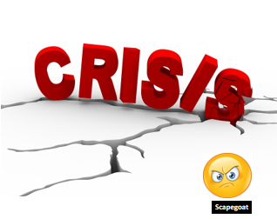 | Now we see that a crisis has occurred.  The crisis is that the Scapegoat has just been suspended from school for smoking pot.
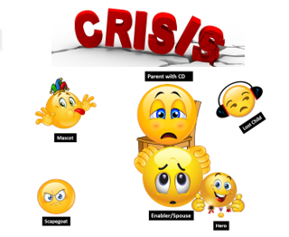 | Let’s think together about how each of the family members might react to this crisis.  How might the Father react?  How might the Enabler react?  How might the Hero react?  How might the Lost Child react?  How might the Mascot react?

What did this activity show us about how chemical dependence affects family members and the roles they take on? Elicit and validate responses from the group

Summarize:
- Children in healthy families try on roles as they develop their personalities.

- The real damage of the roles adopted in the family with chemical dependence lies in their rigidity, with members becoming “stuck” in a role, while at the same time not getting their needs for nurturance, intimacy, attention, and consistency met during their developmental years.

- We have learned that these children carry these roles into adulthood, with damaging consequences for the adult children and those around them.

- Research has proven that, if left untreated, the consequences of these family roles continue to cause problems for the adult children of families with addictions.

- The family sends powerful messages of, “Don’t feel. Don’t talk. Don’t trust.” These messages become the family’s legacy and are carried forth by these damaged adult children.

What will you remember from this activity? Elicit and validate responses from the group

Transition to “Recovery” (p.7-35, #76)

